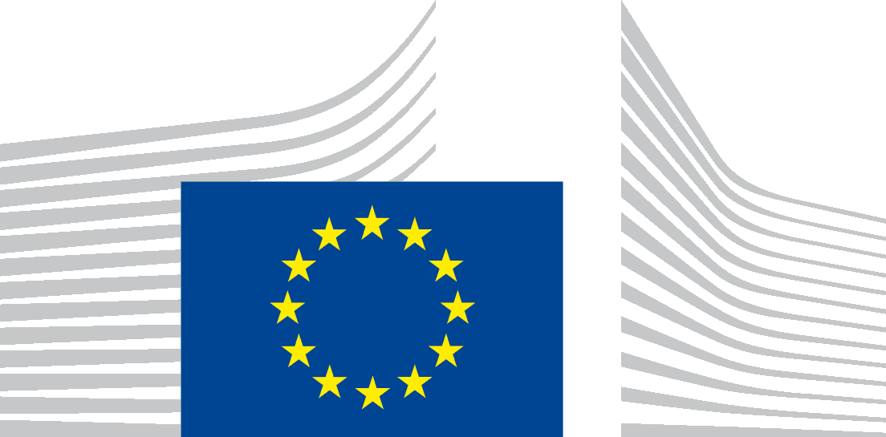 | EUROPEAN COMMISSION  DIRECTORATE-GENERAL FOR EMPLOYMENT, SOCIAL AFFAIRS AND INCLUSION  Skills  Skills and Qualifications
Koen Nomden
Team Leader, Skills and Qualifications

Video message on: the state of play of the EQF and NQFs
NQF as an instrument for transparency and integration of the world of work and the world of education
Belgrade, 16 December 2019
Dear ladies and gentlemen,
I apologize that no Commission representative can be with you in person today, but I am very grateful for the opportunity to address you with this video-message.
I would like to thank the Serbian Ministry of Education, Science and Technological Development, the Agency for Qualifications and the Project for jointly organising the conference on “the NQF as an instrument for transparency and integration of the world of work and the world of education”.
The European Qualifications Framework for lifelong learning (EQF) aims to improve the transparency of qualifications in Europe.
The EQF was set up in 2008 as a common reference framework for qualifications. It was revised in 2017. The EQF contains eight levels that express learning outcomes at increasing levels of proficiency (from level 1 to level 8).
The EQF serves as a translation device between different national qualifications frameworks. It supports the cross-border mobility of learners and workers, and promotes lifelong learning and professional development across Europe.
The EQF makes recognition of qualifications easier, but it does not provide automatic European wide-recognition. It respects the diversity of the education and training landscape and does not aim to harmonise education and training systems.
The EQF, and all National Qualifications Frameworks (NQFs) that have been referenced to it, follow a learning outcomes approach.
The use of learning outcomes is a key element of the EQF and of national qualifications frameworks. In a learning outcomes approach, both the content and the level of a qualification reflect what holders of qualifications are expected to know, understand and be able to do. Learning outcomes make qualifications more transparent and easier to understand, both within and between countries.
The EQF contributes to linking the worlds of work and of education & training
The EQF is a cornerstone of European cooperation on making people’s skills and qualifications more easily understood and recognised when they move either at home or abroad for work or study.
Thanks to the EQF, employers can more easily compare foreign qualifications to national ones and better understand the skills profiles of candidates. The EQF helps people put their talent to use. This supports a better skills match in the labour market.
The EQF is also a tool that can support reform of education and training
The EQF is a reference point for qualifications levels. Across Europe we see that in several countries the setting up of the national frameworks is used as a means to improve the existing qualification system. This focuses mostly on strengthening the quality, coherence and relevance of qualifications. Part of this reform may imply developing new pathways and programmes or changing roles and responsibilities of stakeholders in relation to qualifications. NQFs can also be used as reference points for a more permanent process of review and renewal of qualifications.
Where do we currently stand in the EQF process?
The EQF referencing process has a broad geographical coverage. It includes all EU Member States, the European Economic Area countries (Norway, Iceland, Liechtenstein), the candidate countries and potential candidates to the EU as well as Switzerland.
So far 35 countries have referenced their national framework to the EQF.
Referencing is not a one-off process. It is a permanent activity. National frameworks change over time and therefore referencing to the EQF needs to be updated. The revision of the EQF in 2017 introduced the recommendation to keep the referencing up to date. Latvia, the Netherlands and the United Kingdom have updated their referencing report. In the coming years we expect more countries to follow.
The EQF process is changing in focus
If we look at the EQF since 2008 we can see that the first phase of the EQF mainly consisted of developing national frameworks and their referencing to the EQF. Currently we observe that more and more countries have entered in an operational stage of implementation of their NQF.
This also includes the indication of national and European levels on qualifications. This makes qualifications more transparent to individuals and employers.
This further includes the development of qualification registers, which make information on qualifications transparent to the wider public. Information will include level and, very important: the learning outcomes. All countries in the EQF are invited to interconnect their national database with the European level. So far 24 countries have databases or registers in place. And 12 are currently connected with the European level. Important progress can still be made in this area.
The EQF needs to be seen in a broader context of EU transparency tools
The EQF does not stand alone as a tool. It forms part of a broader landscape of tools. I will address two other tools more in particular, namely Europass and ESCO.
The Commission is currently preparing the new Europass Portal, that will be launched in Spring 2020. Europass will become the main European tool to support lifelong learning and career management. The new Europass will meet all requirements of the digital age and will be based on open standards. It will be available in all official EU languages and be free of use. It will contain an E-portfolio where individuals can manage their skills and from where they can send a CV. It will further contain information, including on qualifications and qualifications frameworks, validation of non-formal and informal learning and recognition of qualifications.
Europass will from its launch also become the official portal of the EQF. After their interconnection, qualifications in NQF registers or databases can be searched in Europass. The Commission will develop tools for comparing qualifications frameworks and individual qualifications in Europass.
I would also like to mention ESCO. This stands for the European Classification of Skills, Competences, Qualifications and Occupations. The ESCO classification was introduced to make job matching possible on the basis of skills. The Commission is currently piloting how learning outcomes of qualifications can be linked to ESCO skills in an automated way. We are also testing ESCO more generally in the context of the new Europass.
Although more than 10 years of EQF have brought a lot of progress (development of NQFs, shift to learning outcomes) important challenges remain.
I will mention, a few:
- Full implementation of the learning outcomes approach: this requires also that teaching and assessment are focussed on learning outcomes.
- The interconnection of databases at European level, so that real transparency of qualifications is achieved.
- The EQF and NQFs are not yet everywhere well known. Policy-makers and experts are not enough. For real impact it is crucial that learners, workers and employers are fully aware of qualifications frameworks and what they can do.
- Finally we see an increasing diversity of learning and qualifications, after initial education. To keep their relevance, frameworks should be open to qualifications not offered by the formal education and training system.
To conclude I would like to say a few words about Serbia
Early November of this year the Serbian colleagues presented a state of play of referencing to the EQF. The presentation reflected the hard and good work carried out in Serbia over the past years. The presentation was well received by the EQF Advisory Group. The full referencing report is planned for presentation in the next EQF AG meeting. This will be early February next year in Brussels. If the review by the EQF AG is positive, Serbia will be the 36th country having referenced to the EQF. That would be an important milestone for many years of preparatory work. We wish you lots of success and courage for the last steps until the presentation of the referencing report.
Finally
I wish you fruitful and constructive discussions, and I look forward to the outcomes of your seminar.

